BU Sports Medicine Staff  General Information: 325 Cherry Ave Main: (731) 352-4000 McKenzie, TN Fax: (731) 352-4238  Jason Essary MAEd, LAT, ATC (901) 283-6685 essaryj@bethlu.edu  Kadin Ricciardi, MS, LAT, ATC (970) 215-0512 ricciardik@bethelu.edu  Nichelle Napier, MA, ATC  (507)402-5355 napiern@bethelu.edu  Tyesha Smith, MS  (228-213-7552 smithty@bethelu.edu  BU Team Doctor  Should you find yourself in need of a physician, please contact a member of the BU Sports Medicine Staff so we can facilitate any appointments that need to be made. Physicians will be present at designated events.  Team Orthopedist: Heather Melton, M.D Twin Rivers Ortho (731) 641-8751 1323 E. Wood St Paris, TN 38242 | Restaurants  McDonalds - (731) 352-0715  Subway - (731) 352-4605  Domino’s Pizza - (731) 352-3000  Sonic Drive-In - (731) 352-3956  Dairy Queen – (731) 352-2454  El Vallerta – (731) 352-0073  Big Daddy’s BBQ – (731) 352-3873  Hotels  Best Western – (731) 352-1083  McKenzie, TN  Hampton Inn – (731) 642-2838  Paris, TN  Paris Landing Inn – 1-800-250-8614  Paris, TN  Hampton Inn – (731) 686-8788  Milan, TN | 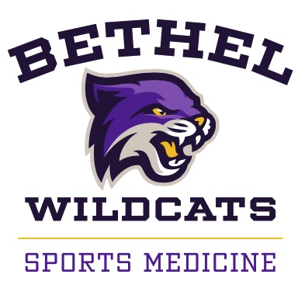  Guide for Visiting Athletic Teams    
Athletic Facilities Utilized By BU  BU Campus: Crisp Arena, Wildcat Stadium, Khalden Complex, Wildcats Courts, Gaines Pool – 325 Cherry Ave (731) 352-4000  Sports: Men’s – Football, Soccer, Basketball, Baseball, Swimming, Tennis, In-Line Hockey, Cross Country, Track and Field, Golf Women’s - Volleyball, Soccer, Basketball, Softball, Swimming, Tennis, Cross Country, Track and Field, Golf Coed – Cheerleading, Shooting, Archery, Fishing, Bowling  Bethel Hockey Complex 19225 Main St. W Huntingdon, TN 38344  Carter Lanes 118 North Main St Paris, TN 38242  Holly Fork Shooting Complex 6133 Hwy 79 N Paris, TN 38242  Brad Chappell – Athletic Director Dave McCulley – Sports Information Director  Visit us at: http://www.bethelathletic.com | Welcome to BU  We would like to take this opportunity to welcome you and your team to Bethel University. Within this brochure, you will find a list of medical personnel and facilities that our team utilizes. You will also find a list of pharmacies and popular restaurants that are easily accessible to the BU campus. Should you have any questions, please feel to contact us. We hope your stay will be both enjoyable and safe.  Sincerely, The BU Sports Medicine Staff | Hospitals  Baptist Memorial Hospital – Carroll County 631 R.B Wilson Drive (731) 986-4461 Huntingdon, TN 38344  Henry County Medical Center 301 Tyson Ave (731) 642-1220 Paris, TN 38242  Hometown Health Clinic 1894 Cedar Street (731) 352-7907 McKenzie, TN 38201  Pharmacies  Phipps Pharmacy (731) 352-0820 205 Hospital Dr. McKenzie, TN 38201  Walgreens (731) 353-7744 14860 Highland Dr McKenzie, TN 38201

